Test Scenario for New Routing Properties, Reasonability-edit Bypass By Class and Post/Station

Test Setup

Form the Routing Properties Window, go to the Class Tab and add Reasonability-edit Bypass By Class as follows;

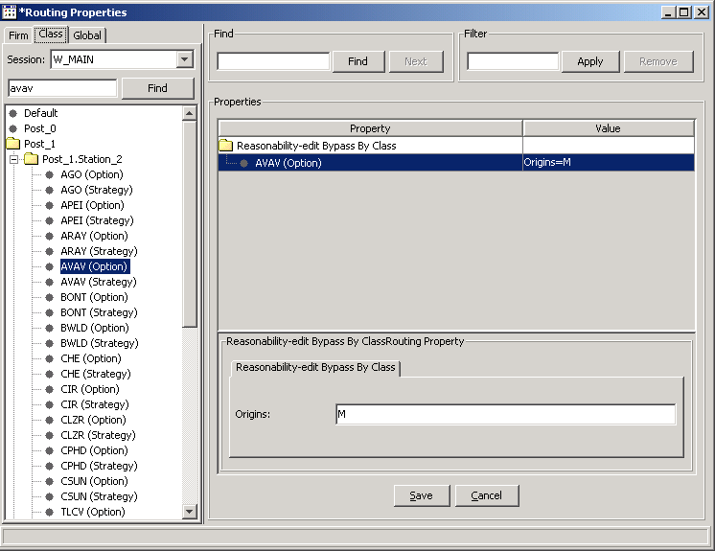

From the Product Window, change the product state to Open Rotation as follows;

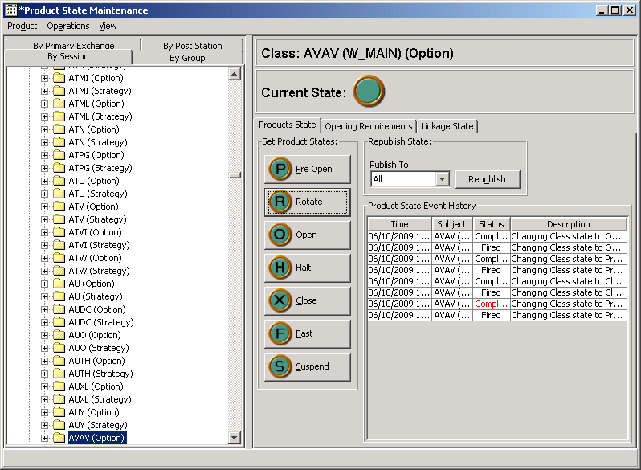

Test Case 1:

From the Trader GUI, select a product with state “Opening Rotation” and enter an order with the origin “Market Maker” as follows:

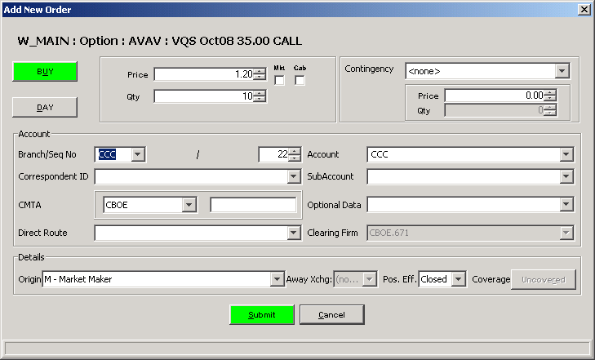

Verification:

- Go to the BC box in your test environment, open the log file, OHServerHybrid.audit, and look for your order with the branch and branchsequencenubmer: CCC:22
- Look for the string PASS_RESOANABILITY_EDIT. You should see the following line in GREEN:

2009-06-10 14:01:38.570 AUDIT WorkflowHome [IIOPTransportServerThreadPool-WorkerThread(6)] Executed step(validateMKTOrder) result(BYPASS_MARKET_ORDER_CHECK)
2009-06-10 14:01:38.570 AUDIT WorkflowHome [IIOPTransportServerThreadPool-WorkerThread(6)] Executed step(checkIfReasonabilityEditisNeeded) result(BYPASS_REASONABILIT
Y_EDIT)
2009-06-10 14:01:38.570 AUDIT WorkflowHome [IIOPTransportServerThreadPool-WorkerThread(6)] Begin workflow(volumeDeviationCheckWF) for context(CBOE:671:CCC:22::200906

Test Case 2:

- From the Trader GUI, select a product with state “Opening Rotation” and enter an order with the origin “Broker/Dealer” as follows:

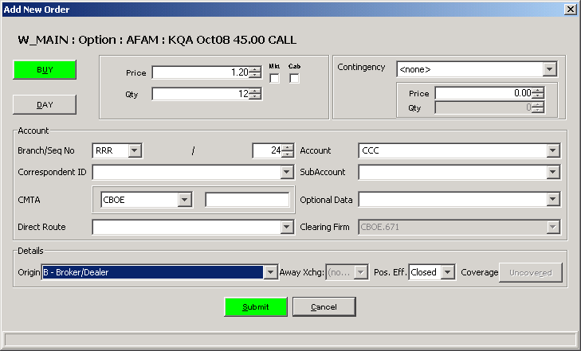

Verification:

- Go to the BC box in your test environment, open the log file, OHServerHybrid.audit, and look for your order with the branch and branchsequencenubmer: RRR:24
- Look for the string PERFORM_RESOANABILITY_EDIT. You should see the following line in GREEN:

2009-06-10 14:02:22.683 AUDIT WorkflowHome [IIOPTransportServerThreadPool-WorkerThread(5)] Executed step(validateMKTOrder) result(BYPASS_MARKET_ORDER_CHECK)
2009-06-10 14:02:22.683 AUDIT WorkflowHome [IIOPTransportServerThreadPool-WorkerThread(5)] Executed step(checkIfReasonabilityEditisNeeded) result(PEFORM_REASONABILIT
Y_EDIT)

Test Case 3:

Select a product and enter a quote to open the product as follows, then create an order with the origin “Market Maker” below:

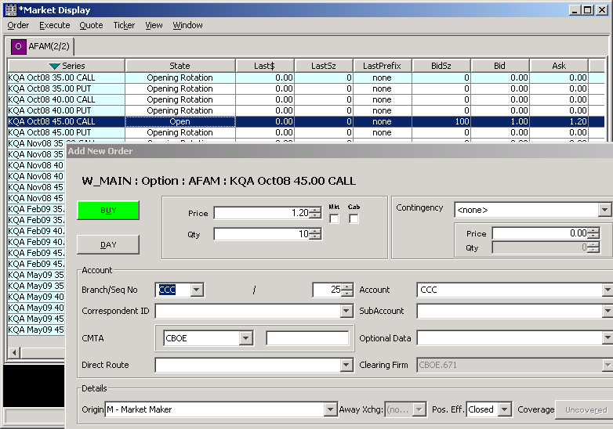

Verification:

- Go to the BC box in your test environment, open the log file, OHServerHybrid.audit, and look for your order with the branch and branchsequencenubmer: CCC:25
- Look for the string PERFORM_RESOANABILITY_EDIT. You should see the following line in GREEN:

2009-06-10 14:25:00.678 AUDIT WorkflowHome [IIOPTransportServerThreadPool-WorkerThread(5)] Executed step(checkIfReasonabilityEditisNeeded) result(PEFORM_REASONABILIT
Y_EDIT)
2009-06-10 14:25:00.679 AUDIT WorkflowHome [IIOPTransportServerThreadPool-WorkerThread(5)] Executed step(checkSuperMktable) result(NOT_SUPERMARKETABLE)

Test Setup:

- Remove the Reasonability-edit Bypass By Class setting
- Add the Reasonability-edit Bypass By Post/Station as follows:

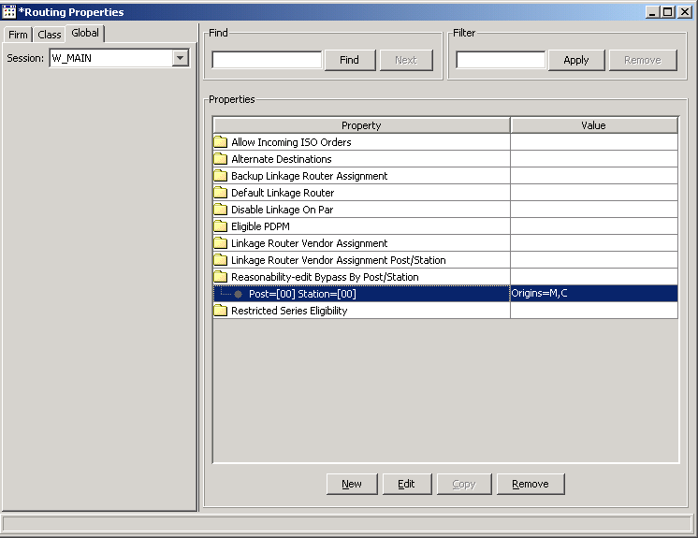

Test Case 4:

- From the Trader GUI, select a product with state “Opening Rotation” and enter an order with the origin “Broker/Dealer” as follows:

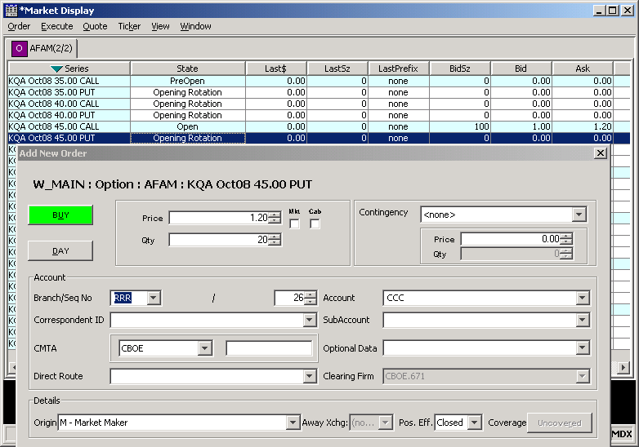

Verification:

- Go to the BC box in your test environment, open the log file, OHServerHybrid.audit, and look for your order with the branch and branchsequencenubmer: RRR:26
- Look for the string BYPASS_RESOANABILITY_EDIT. You should see the following line in GREEN:

2009-06-10 14:33:40.268 AUDIT RoutingPropertyServiceHome [IIOPTransportServerThreadPool-WorkerThread(3)] Reasonability Edit Bypass By Class: property not found
2009-06-10 14:33:40.268 AUDIT RoutingPropertyServiceHome [IIOPTransportServerThreadPool-WorkerThread(3)] ReasonabilityEditBypassPostStationHandler: property not foun
d
2009-06-10 14:33:40.268 AUDIT WorkflowHome [IIOPTransportServerThreadPool-WorkerThread(3)] Executed step(checkIfReasonabilityEditisNeeded) result(BYPASS_REASONABILIT
Y_EDIT)

Test Case 5:

- From the Trader GUI, select a product with state “Opening Rotation” and enter an order with the origin “Broker/Dealer” as follows:

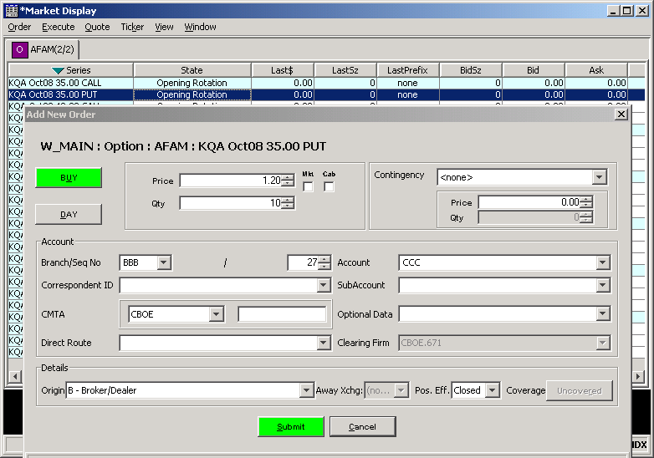

Verification:

- Go to the BC box in your test environment, open the log file, OHServerHybrid.audit, and look for your order with the branch and branchsequencenubmer: BBB:27

- Look for the string PERFORM_RESOANABILITY_EDIT. You should see the following line in GREEN:

2009-06-10 14:37:44.503 AUDIT WorkflowHome [IIOPTransportServerThreadPool-WorkerThread(2)] Executed step(checkIfReasonabilityEditisNeeded) result(PEFORM_REASONABILIT
Y_EDIT)
2009-06-10 14:37:44.503 AUDIT ReasonabilityEditHome [IIOPTransportServerThreadPool-WorkerThread(2)] Pre-Open State, will use Closing price to calculate super marketa
bility =1.50
2009-06-10 14:37:44.503 AUDIT WorkflowHome [IIOPTransportServerThreadPool-WorkerThread(2)] Executed step(checkSuperMktable) result(NOT_SUPERMARKETABLE)
:

Test Case 6:

- From the Trader GUI, select a product with state “Open” and enter an order with the origin “Market Maker” as follows:

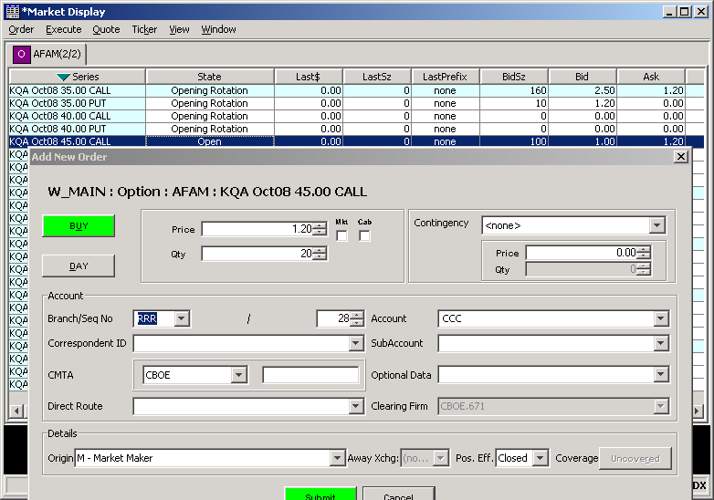

Verification:

- Go to the BC box in your test environment, open the log file, OHServerHybrid.audit, and look for your order with the branch and branchsequencenubmer: RRR:28

- Look for the string PERFORM_RESOANABILITY_EDIT. You should see the following line in GREEN:

2009-06-10 14:42:57.982 AUDIT WorkflowHome [IIOPTransportServerThreadPool-WorkerThread(5)] Executed step(checkIfReasonabilityEditisNeeded) result(PEFORM_REASONABILIT
Y_EDIT)
2009-06-10 14:42:57.982 AUDIT WorkflowHome [IIOPTransportServerThreadPool-WorkerThread(5)] Executed step(checkSuperMktable) result(NOT_SUPERMARKETABLE)

